CPP 1001_13

Pedro Fernandes

C0676975

Assignment 4 – Job Post/Certificate

This is the picture of the certificate acquired on:

<http://www.labour.gov.on.ca/english/hs/elearn/worker/index.php>

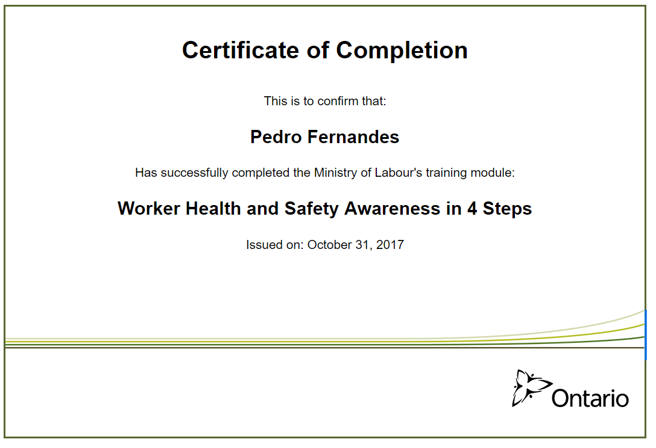

Those 2 pictures are from a job posting posted on Lambton MyCareer website.

